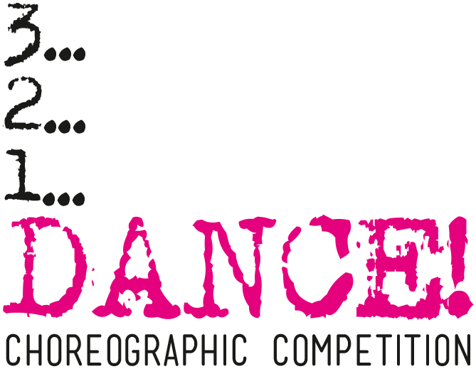
APPLICATION FORM

Choreographic competition 3…2…1…DANCE! 2019

- Title of the work:
- Name and surname of choreographer(s):
- Date of birth of choreographer(s):
- Country of creators’ origin:
- Country in which the presentation was created:
- Form of presentation (solo, duet, trio):
- Name and surname of dancer(s):
- Date of birth of dancer(s):
- Duration of the presentation:
- Link to the video of presentation (e.g. YouTube, Vimeo):
- Premiere place and date:
- Technical notes (props or elements that are used and need to be cleaned after the presentation etc.):
- Short work description (max. 6 sentences):
- Information about the authors of the work (max. 6 sentences about each):
- Information about the music used in the presentation (ZAIKS):

Title of track | Name of composer | Lyrics’ author | Music performer

Contact address:
Phone number:
E-mail:
Bank account number (IBAN, SWIFT):

How to apply:

- Fill the application form.
- Pay the application fee:

Krakowskie Centrum Choreograficzne
Nowohuckie Centrum Kultury
al. Jana Pawła II 232
31-913 Kraków
PKO Bank Polski SA
08 1020 2892 0000 5602 0591 0130
IBAN: PL08102028920000560205910130
SWIFT: BPKOPLPW

with a note: application fee 3…2...1…DANCE! + name and surname of the choreographer

- Send the filled application form and the confirmation of payment via email: kcc@nck.krakow.pl (title of mail: 3…2…1…DANCE! – application for the competition)

- Print the filled application form and Rules & Regulations, sign both documents and send them via traditional post:

Krakowskie Centrum Choreograficzne
Nowohuckie Centrum Kultury
al. Jana Pawła II 232
31-913 Kraków
with a note: 3…2...1…DANCE! – application

- All above things should be done till 13th of February 2019. According to point 4., the date on the postmark is decisive.
- Submitting the application means that you accept Rules & Regulations of the competition available on the website www.nck.krakow.pl/kcc/en/.

According to Regulation (EU) 2016/679 of the European Parliament and of the Council of 27 April 2016 on the protection of natural persons with regard to the processing of personal data and on the free movement of such data (General Data Protection Regulation) and in accordance with the Act of 10th May 2018 on the Protection of Personal Data. I consent to processing of my personal data and personal data of the persons indicated in the application form, in the purpose of organizing and conducting the Competition by Nowa Huta Cultural Centre, including identification of candidates, participants and other people connected with the Presentations, conducting the Eliminations and the Competition, as well as selecting the laureates.

…………………………………………………..
Signature of the choreographer

I consent to unpaid publish of my image and image of other people indicated in the application form in non-commercial materials presenting the work of the Organizer, posted on the website and in information materials in the form of print, video and film.

…………………………………………………..
Signature of the choreographer

ZAIKS - Polish Society of Authors and Composers (Związek Autorów i Kompozytorów Scenicznych, ZAiKS) is a Polish organization representing artists and composers with the mission of "defending their copyrights".

